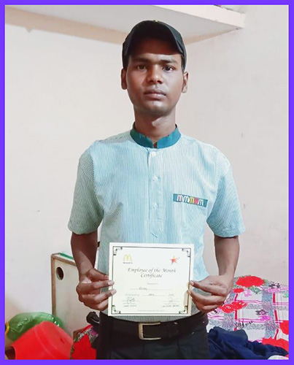

**ETASHA alumni Vikash is super charged and happy! He has won the Employee of the Month Award that too within the first two months of his joining Mc Donald's. “Initially it was tough and a lot of hard work but then I saw everyone around me doing the same job and this motivated me to not give up and continue. I like to be a part of a team and enjoy working with my co-workers. The award has made me a hero for my five brothers. I am the youngest and they all are very proud of me. I will treat my family to a dinner.”**

**So, how did ETASHA’s training help him?**

**“I learnt how to be punctual as that was a big issue with me initially. ETASHA's Vision and Mission classes helped me realize that retail and hospitality could be possible fields for me to explore. I also learnt the value of grooming, etiquettes and how to dress up formally. The grooming sessions attended at ETASHA are really helping me at my workplace now,” says Vikash.**

**ETASHA congratulates Vikash for his perseverance and dedication!**

***Let’s make many more like Vikash stand on their feet with dignity and pride.***

***Let’s Together #FightBerozgaari***

***Contribute Generously to help ETASHA provide Skilling and Sustainable Employment to the marginalised:-***

[***http://etashasociety.org/contribute/***](http://etashasociety.org/contribute/?fbclid=IwAR3wBbmjNmg3rgog5Pn3-sdbCvOHfguBCSX1W3C2QGZq4Kwju3NZagBxGkw)

***Keep yourself updated with what’s latest at ETASHA***

[*https://www.facebook.com/etashasociety*](https://www.facebook.com/etashasociety)

[*https://twitter.com/etashasociety*](https://twitter.com/etashasociety)

[*https://www.linkedin.com/in/etashasociety*](https://www.linkedin.com/in/etashasociety)

[*https://www.instagram.com/etashasociety/*](https://www.instagram.com/etashasociety/)

[*https://www.youtube.com/user/ETASHAIndia*](https://www.youtube.com/user/ETASHAIndia)

***Happy to connect and collaborate.***

Best Wishes

**Meenakshi Nayar**

           President - ETASHA Society